Project Overview —SortiFy: Elderly Grocery Sorting Robot
Sortify is an AI-powered assistive robot built using the Yahboom DOFBOT AI Vision Robotic Arm.
It aims to help elderly individuals organize their groceries safely and efficiently after shopping.
The system combines computer vision, deep learning classification, and robotic manipulation to automatically detect, identify, and place grocery items into the correct containers.
🧠 Concept
- The elderly person places each grocery item on a designated pick zone.
- The Pi Camera mounted on the DOFBOT captures the item image.
- A YOLOv8 classification model identifies the grocery type.
- Based on the predicted class, the DOFBOT performs inverse kinematics to move the arm, grasp the item, and place it into its corresponding color-coded container.
This system reduces physical effort and cognitive load for elderly users while demonstrating how robotics and AI can enhance daily independence.

Dataset & Model Training
- Classes used (6): Bottle, Can, Detergent, Pulses, Seafood, Vegetable
- Dataset composition: ≈500 images per class (train/val/test split 70/15/15).
- Model used: YOLOv8-Classification (yolov8n-cls)
- Input resolution: 224×224 px (optimized for Raspberry Pi performance).
- Training details:
  - Transfer learning from pretrained YOLOv8 weights.
  - Applied augmentations: rotation, brightness/contrast jitter, flips.
  - Trained for 50 epochs with early stopping on validation loss.

📊 Performance Results
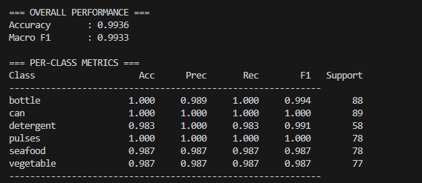

Confusion Matrix Summary:
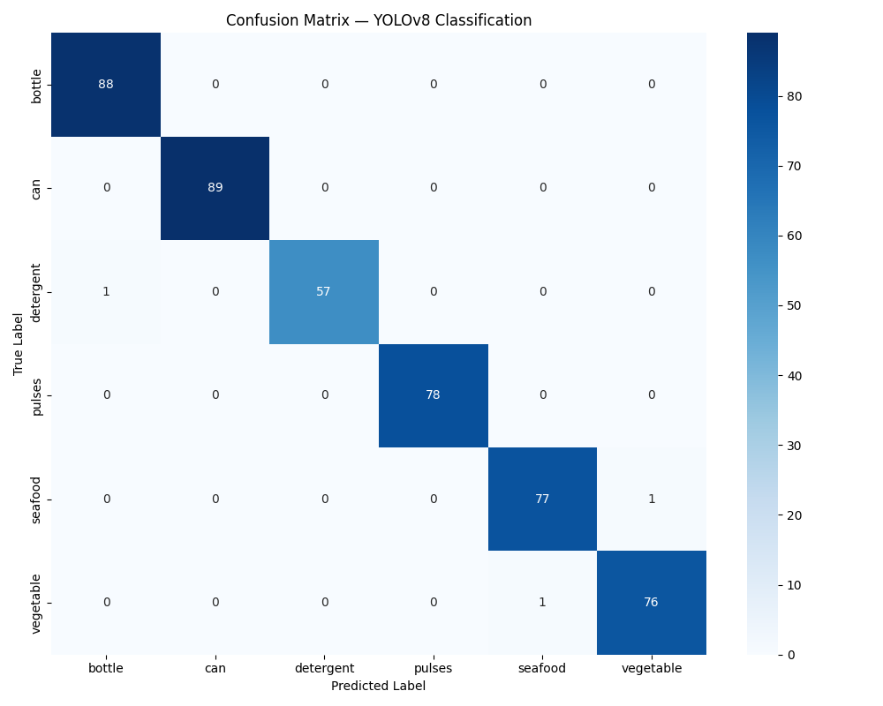
- Nearly perfect diagonal accuracy across all classes.
- Only three minor misclassifications (detergent ↔ bottle, seafood ↔ vegetable).
- Indicates strong generalization and balanced learning.
These results confirm that the model is robust enough for real-time inference (> 5 FPS) on the Raspberry Pi, making it ideal for the DOFBOT’s onboard deployment.

⚙️ Robot Implementation Plan (Next Steps)
1. Hardware Setup
- Mount DOFBOT on a 60 × 40 cm platform.
- Define Pick Zone (central region) and six sorting bins arranged in reachable positions (as shown in the layout diagram).
- Fix Pi Camera to capture the Pick Zone entirely within its field of view.
2. Software Integration Workflow
Step-by-Step Workflow
- Start / Idle – System waits for an object to appear in the Pick Zone.
- Capture Frame – Camera captures the item image.
- Classification – YOLOv8-cls model predicts grocery class and confidence.
- Decision Logic – Assigns the corresponding bin coordinate.
- Motion Planning – Compute inverse-kinematics path to target bin.
- Pick and Place – Arm closes gripper, lifts, moves via mid-waypoint, releases item in bin.
- Return Home – Arm resets to initial position for the next object.
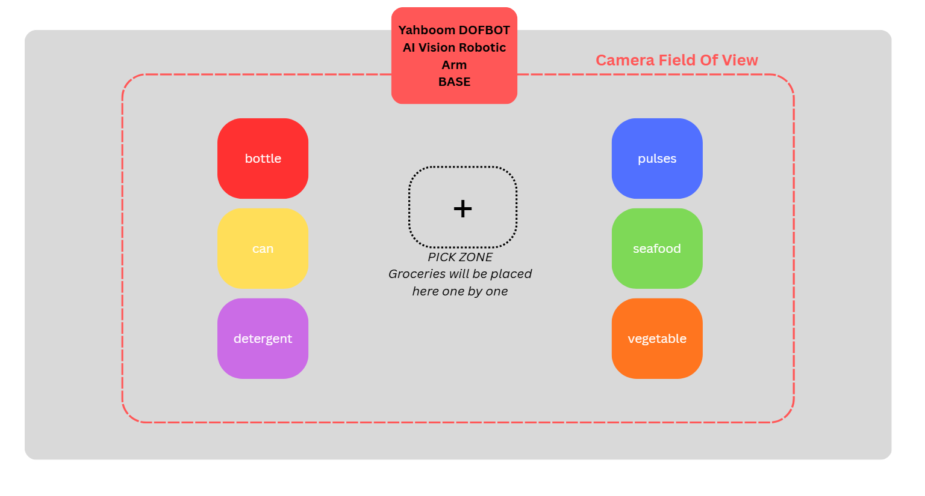

Achievements to Date
✅ Dataset collected and annotated for 6 grocery classes.
✅ YOLOv8 Classification model trained and evaluated with > 99 % accuracy.
✅ Layout of physical workspace designed (bins, pick zone, camera FOV).
✅ Flask web interface created for live image classification.
✅ Clear plan defined for integrating classification output with robotic control.

Next Phase — Full Robot Integration
- Deploy trained model on Raspberry Pi 5.
- Implement Python scripts for classification → motion control pipeline.
- Test grasping and sorting in the real setup.
- Add voice or LED feedback for elderly usability.
- Record demonstration video for coursework submission.

